26.02.
printerhead test

download arduino IDE
https://www.arduino.cc/en/Main/Software

To know which software you have to install, type to terminal:
uname -a
This command shows information about your computer

arduino IDE setup and rosserial_arduino package:
http://wiki.ros.org/rosserial_arduino/Tutorials/Arduino%20IDE%20Setup
“It allows your Arduino to be a full fledged ROS node which can directly publish and subscribe to ROS messages, publish TF transforms, and get the ROS system time.”

1. set arduino sketchbook

2. installing binaries on the ROS workstation
sudo apt-get install ros-melodic-rosserial-arduino
sudo apt-get install ros-melodic-rosserial

installing rosserial to staubli_ws:
cd <staubli_ws>/src
git clone https://github.com/ros-drivers/rosserial.git
cd ..
catkin build
catkin config --install

ROS Node and Arduino Code to control RAMPS 1.4 Steppers with ROS Control
https://github.com/Hacks4ROS/h4r_ramps

NO, DON’T DO IT THAT WAY. Previous idea was to create new software in arduino, so it could control printer head.

27.02
NEW goal:
Study Marlin and try to control printer. First, try to blink LED on Arduino or something, to understand how everything works. After that, try to create ROS node to send mesages/commands to Arduino with Marlin. Send and receive messages.
https://answers.ros.org/question/10114/how-can-ros-communicate-with-my-microcontroller/

“rosserial is a protocol for wrapping standard ROS serialized messages and multiplexing multiple topics and services over a character device such as a serial port or network socket.”
https://wiki.ros.org/rosserial

Rosserial arduino
http://wiki.ros.org/rosserial_arduino/Tutorials

28.02.2020

1. Understand marlin and try to make it do something using g-code
2. Do rosserial/rosserial_arduino tutorial.
3. Maybe now I have enough knoweledge and skills to create node and make things work in ros?

Install arduino
install ponterface (printrun)
sudo apt-get install -y printrun
sudo apt-get install -y printrun

pronterface communication fix. To have access:
https://github.com/kliment/Printrun/issues/671

In prompt:
ls -lah /dev/ttyUSB0
→ crw-rw---- 1 root dialout 188, 0 Feb 28 13:07 /dev/ttyUSB0
→ user not in dialout

add user to group dialout:
sudo gpasswd -a (myusername) dialout

in pronterface

Port:
/dev/ttyUSB0

@:
9600

This could be useful. Marlin configuration. Set parametres – thermal settings, extruder etc. with explanations:
https://marlinfw.org/docs/configuration/configuration.html#configuring-marlin

“provide a scheme for real-time communication between the simulation and real robot.” There could be possibly useful information, which we could take to our project. GitHub link included inside the project.
https://www.jesseweisberg.com/moveo-with-ros

Arduino tutorial serial io:
https://www.norwegiancreations.com/2017/12/arduino-tutorial-serial-inputs/

Could be useful examples, for example it is possibly to use with some modifications “Program two Arduino boards to communicate with one another in a Master Reader/Slave Sender configuration via the I2C.” :
https://www.arduino.cc/en/Reference/Wire

Creating packages and nodes
https://industrial-training-master.readthedocs.io/en/melodic/_source/session1/Creating-a-ROS-Package-and-Node.html
OR
https://husarion.com/tutorials/ros-tutorials/2-creating-nodes/

subscriber, publisher, messages
https://www.youtube.com/watch?v=GxpS18INc9s&feature=youtu.be

Hello!

I'm building a 6-axis 3d printer. **6-axis robot is ROSified** and it is Staubli TX40 with CS8 controller.

At this moment, **my task is to make printerhead work with 6-axis robot using ROS.**
Printer specs are:

Arduino MEGA 2560 with RAMPS 1.4 shield, running marlin 1.1.x.
At the RAMPS 1.4 shield is plugged step motor (EXTRUDER 0), DRV8825 Stepper Motor Driver Carrier, and heater to (THERMISTORS).
There is also S-360-12 Power Supply.

I'm using Ubuntu 18.04 and ROS melodic.

**Printer part has been taken from other similar robot, which was fully working, but not using ROS.** Staubli robot is connected to the laptop with RS232 cable, and i'm planning to connect Arduino to my laptop using USB.

**So my question is,** how can i do that and what are the options?

My vision is, that i'm not touching Arduino's hardware and software, keeping Marlin inside. Computer is working as a master, and i have to create a node(?) to communicate with printer and send the G-code. Printer is reading G(?) E and F data from the G-code and print using this information. So, basically i have to create communication work between the computer and Arduino/RAMPS using ROS? Am i thinking in right direction?

Correct me if i'm wrong or if you know better solution, and can someone give me a tips in what direction i should move/how i can do it? I'm not so long in ROS.

Maybe someone allready did that, and there is a similar project somewhere, which i didn't find?

Thank you in advance for help!

Also i tried to send G-code to printerhead (Arduino/Marlin) using Pronterface, and it started printing, so it works and is configured. (NOT with ROS)

ros-melodic arduino Ubuntu18.04 print ramps 6-dofRobot
https://answers.ros.org/question/345746/how-to-add-3d-printer-arduinomarlin-to-my-robot-using-ros/

ROS Node and Arduino Code to control RAMPS 1.4 Steppers with ROS Control
https://github.com/Hacks4ROS/h4r_ramps
(Not the thing we want, but maybe we could use this as an info)

Rosserial/arduino Pub&Sub /Q example
https://answers.ros.org/question/10645/rosserialarduino-publishers-and-subscribers/

moveo_moveit_arduino.ino subscriber, but with the gripper and 5 joints (No that’s not it again)
https://github.com/jesseweisberg/moveo_ros/blob/master/moveo_moveit/moveo_moveit_arduino/moveo_moveit_arduino.ino

Ramps shield pins and other info:
http://domoticx.com/arduino-mega-shield-ramps/
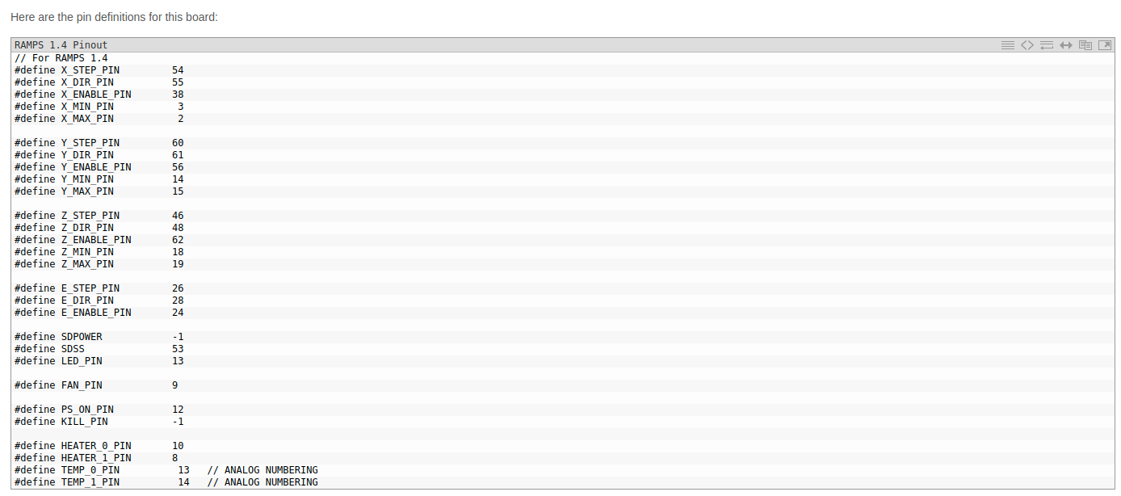
Rosserial_arduino example subscriber:
http://wiki.ros.org/rosserial_arduino/Tutorials/Blink

Maybe useful command in the future, when using rosrun and connecting using terminal to arduino. I mean last command, to match baud rate
rosrun rosserial_python serial_node.py /dev/ttyUSB0 _baud:=9600

First, create a publisher to send values to the printer. Just after that try to create a subscriber

Try to send to the printer
rostopic pub [topic] [msg_type] [args]
for example in turtlesim:
rostopic pub -1 /turtle1/cmd_vel geometry_msgs/Twist -- '[2.0, 0.0, 0.0]' '[0.0, 0.0, 1.8]'
(-1 explanation: This option (dash-one) causes rostopic to only publish one message then exit:)
more here:
http://wiki.ros.org/ROS/Tutorials/UnderstandingTopics

12.03.2020
I got c++ program, which could send g code to arduino/marlin.

Try catkin
https://answers.ros.org/question/67110/how-to-succesfully-catkin_make-with-files-that-include-header-files-c/

Compile & run
sudo g++ printertool.cpp mySerial.cpp
./a.out

update github:
git status
git add .
git commit -m "init commit"
git push -f origin master

Integrating ROS with an existing C++ code base
https://answers.ros.org/question/301171/integrating-ros-with-an-existing-c-code-base/

Publish data of an existing C++ project into a ROS topic. Rosbridge, linking roscpp etc.
https://answers.ros.org/question/163886/publish-data-of-an-existing-c-project-into-a-ros-topic/

(no, ROS
http://wiki.ros.org/rosbridge_suite
18.3.

Barbini:

He uses cura to slice 3d model. Page 17. https://www.youtube.com/watch?v=eUNTlb5pEWA

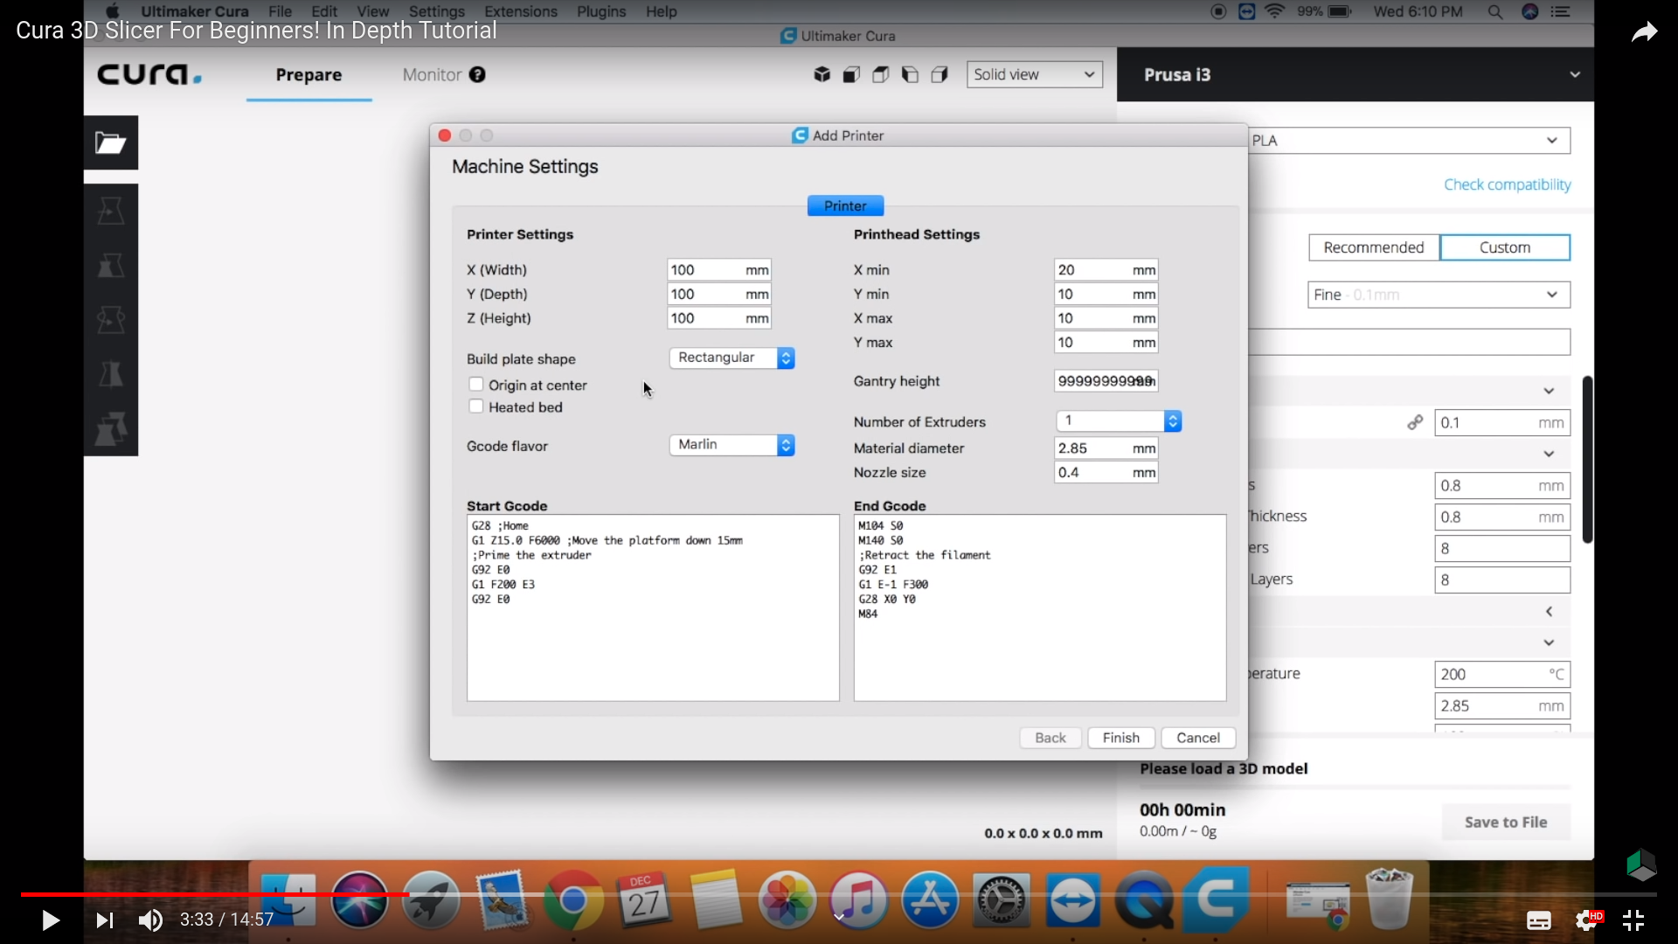
Staubli runs on VAL 3 language. Maybe V+ is something similar, that we use in our case like ros & other tools?

Barbini didn’t use messages in both directions. It is possible to make, but he didn’t need it in this type of project.

As I understood, Barbini used to send 2 “coordinate” files to the machine. 1 with marlinfriendly gcode format, and other with staublifriendly (maybe v+) file.v2. Both are based on same model, they are just formatted so the printer and staubli understands commands.

Descartes_manufacturing.cpp is taken from here
https://github.com/ros-industrial-consortium/descartes_tutorials/blob/master/descartes_tutorials/src/tutorial1.cpp

VSCode & ROS c++
https://answers.ros.org/question/282295/how-to-setup-intelisense-on-vs-code-for-ros-c/

https://marketplace.visualstudio.com/items?itemName=ms-iot.vscode-ros

drueg code line 157

step 1 create gcode for staubli.

control speed of the staubli and marlin.

1. Force marlin to print 40mm.
2. Control the speed of movement of the robot so it is same. Look at descartes_manufacturing.cpp.
3. Gcode what Barbini used has x, y, when layer changes then z. David uses xyzijk. From the barbini g-code (ex. Arm.gcode), we need to create correct information like xyzijk and be able to read the gcode (make robot to move in this directions).
4. later is synchronization.

TO ROSRUN PRINTER
In staubli_ws
catkin build
source devel/setup/bash
rosrun printer printer_printertool

Change from gcode
F = Feedrate
printSpeed = 40
diamBuse = 0.4
hCouche = 0.2
diamFil = 1.75

feedRate = (60 * 4 * diamBuse * hCouche * printSpeed)/(math.pow(diamFil, 2) * math.pi)

feedrate = (60 * 4 * 0.4 * 0.2 * 40) / (1.75^2 * PI) = 79.82432411…….
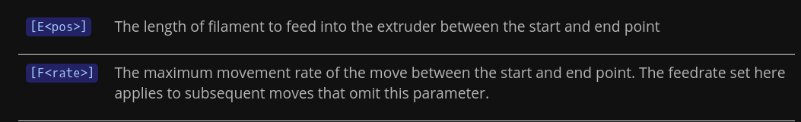
https://marlinfw.org/docs/gcode/G000-G001.html

!!!!!!!!!!!!!!!!!!!!!!!!!!!!!!!!!!!!!!!!!!!!!!!!! NOTE !!!!!!!!!!!!!!!!!!!!!!!!!!!!!!!!!!!!!!!!!

There could be possible this scenario, that marlin needs F in every line of gcode. Maybe printing apps is keeping this parameter in “memory” and sending new F when it need to be changed, but because we are sending line by line, it is not in our memory. So if in the future there will be a problems with “glitching printing”, then this is probably the issue! Maybe all Gx should be G0 too?
24.3.2020

PRINTER SUMMARY:

Now we are able to read and send Gcode to the USB port. We have to set the right usb port and baudrate in the printertool.cpp. And define the type how we would get the Gcode. For example - from the same folder, from absolute path, or ask user to enter path and Gcode filename.

After we are getting the gcode, program changes existing E and F parameters. In our case, we are forcing printer to print at same speed all the time. We define our printer parameters, and choose the speed we need. Mathematical diagram for calculation is:
F = feedrate = (60 * 4 * diambuse * hcouche * printspeed)/(diamfil^2 * pi)

If you are changing in the future some parts from the printer, for example you have filament with different thickness, change different sized nozzle or you want to change printing speed, you can change printer parameters in the beginning of printertool.cpp.

With new F value, we overwrite existing F value in the gcode, and send our new calculated values to the marlin printer.

In the sliced Gcode, we have growing E parameters, so our program calculates current E parameters – previous E parameters, and we are getting current E parameter that we need to execute in the marlin.

We could have communication in both direction, but in our project we don’t need it. But this is possible to do, if it will needed in the future.

If we have problems in the future with the printertool while printing, the problem could be, that the Gcode we send is not sending feedrate (F) values in every line. So if you have problems in the future, add to the printertool.cpp function, where it adds F parameters in every line before it is sending it to the USB port, where it is not defined. Possibly G1 parameter should be changed to G0 too.
Stauli notes starts here!

We need to controll the movement speed of the robot. We have to find the way, how to force Staubli to move in the forced speed. We also have to be able to send .gcode file to the staubli in the right shape, so the staubli will understand the points. In our existing .gcode file, we have X Y Z parameters. X and Y is seen in every line, but Z is showing only in one line, when it is changing the layer. So we have to be able to add Z coordinates in every line, which is taken from the first layer, and is changing every time layer will change. Coordinates should be the same, so we don’t need to calculate them differently. I J K – these paremeters we should send to the Staubli too, so we have to add this at the end of the line we send to the robot. In our case, we can add 0,180,0. Format should be:
X0.1 Y0.2 Z0.4 I0.0 J0.0 K1.0
X0.1 Y0.4 Z0.4 I0.0 J0.0 K1.0
…

New Tutorial on Time Parameterization / Speed Control
https://github.com/ros-planning/moveit_tutorials/pull/50/

LINE 223
Robot movement speed changes, when we change delta time in descartes_manufacturing line 223. But maybe that is affecting to the time between the points, so will speed be different if the distance is shorter/longer?

// If not defined, the delta time used to get to next pose
const static double dt = 20.0;

LINE 150
Atleast in simulation, this is not visually affecting to anything. Rad/s = Rotation speed. And this is limiting aswell, not setting.
// Define a default velocity. Descartes points without specified timing will use this value to limit the
// fastest moving joint. This usually effects the first point in your path the most.
const static double default_joint_vel = 0.5; // rad/s

http://wiki.ros.org/descartes/Tutorials/Getting%20Started%20with%20Descartes

Check MoveIt

David changed from line 181 M_PI/2.0, // Search discretization - to 12.0 (previously of course parts names that we are using, for example nodename from descartes_tutorial to descartes_manufacturing etc tools etc), and added lines 184-250…?

LINE 183
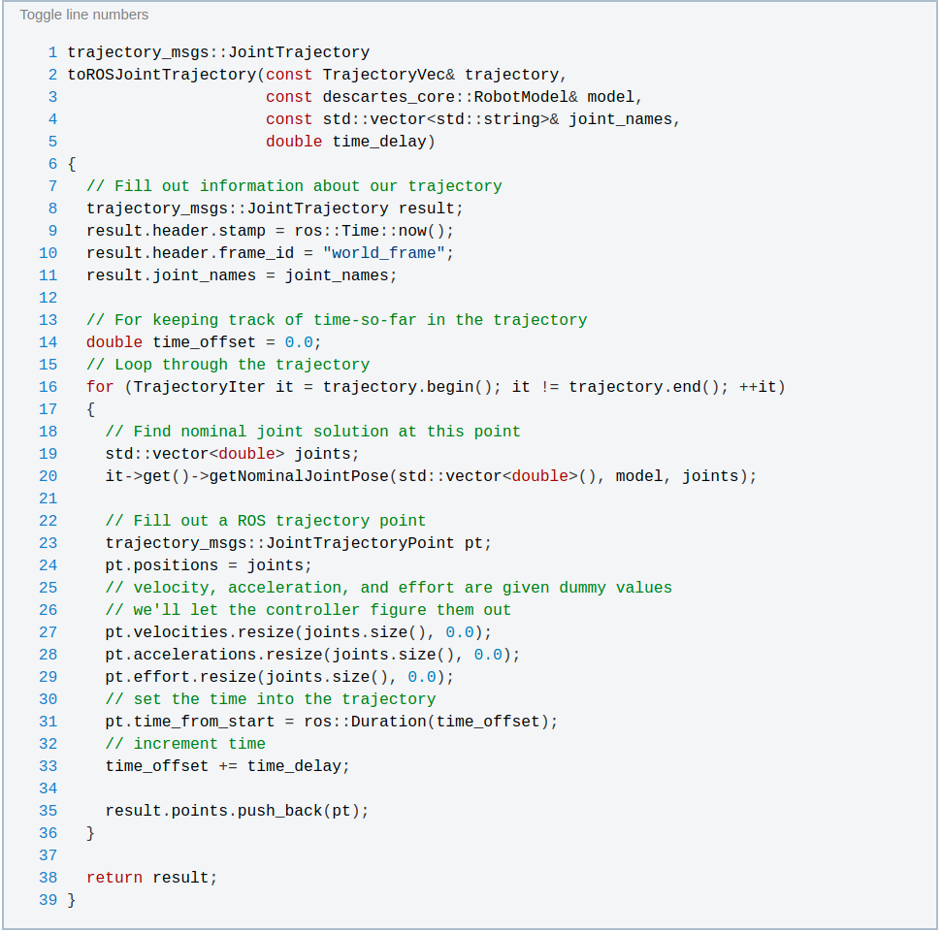
If we look at wiki.ros.org descartes tutorial, there has been:
There is parameters to set velocity, acceleration and effort, but they are dummy values, and controller figure them out. Why those lines had been removed, and how we can force that this is the values we need?
“Next, we resize the velocity, acceleration, and effort fields and set all values to zero so that the controller will not reject our points and will hopefully figure out these values on its own.”

VSCODE COMPILATION ERROR →
fatal error: ros/ros.h: No such file or directory
caused by header #include <ros/ros.h>

This error accur because when compiling, vscode is not seeing cmakelist and other ros parts. There is ways to fix this downloading ros library, but easier way is to compile using terminal command catkin build
http://docs.ros.org/melodic/api/moveit_tutorials/html/doc/time_parameterization/time_parameterization_tutorial.html

MoveIt! is currently primarily a kinematic motion planning framework - it plans for joint or end effector positions but not velocity or acceleration. However, MoveIt! does utilize post-processing to time parameterize kinematic trajectories for velocity and acceleration values. Below we explain the settings and components involved in this part of MoveIt!

